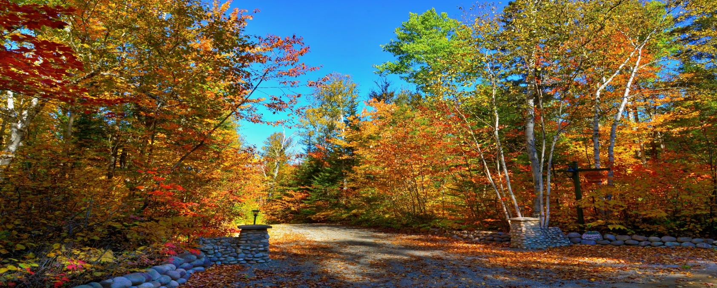

SERFSN are providing information & wellbeing sessions online in November

Mental Health Engagement

Thursday 12th November 2020, 2pm
Paul Fallon, Area Leader for Mental Health Engagement, South East will provide information on
Understanding mental health services in south east, what are the community mental health service & how to access them.

Nature Eco Wellbeing Workshop

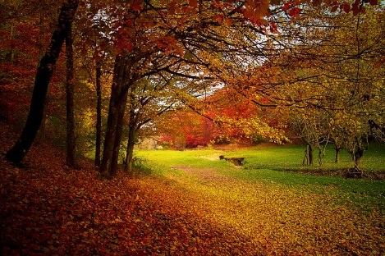
Saturday 21st November 2020, 2pm

Shirley Gleeson, Eco wellbeing consultant will facilitate an online workshop on how contact with nature can build resilience.
The workshop will include:
1) The health benefits of spending time in nature
2) Nature for Self-care
3) Strengthening your connection with nature to enhance coping.
4) Nature based tools and sign posting to resources

